Agent Registration

**#1**

* *Name- John Paul*
* *DOB- 12/12/1996*
* *Date-of-join - 08/09/2018*
* *Contact – 8031996007*
* *Email –* [*john@gmail.com*](mailto:john@gmail.com)
* *City - Chennai*
* *State - Tamil Nadu*
* *Pin code – 600119*
* *Current Address – rock center,9th avenue, Chennai*
* *Permanent Address- rock center,9th avenue, Chennai*
* *Type of proof - Passport*
* *Passport no – J8369854*
* *Agent type – Captive*

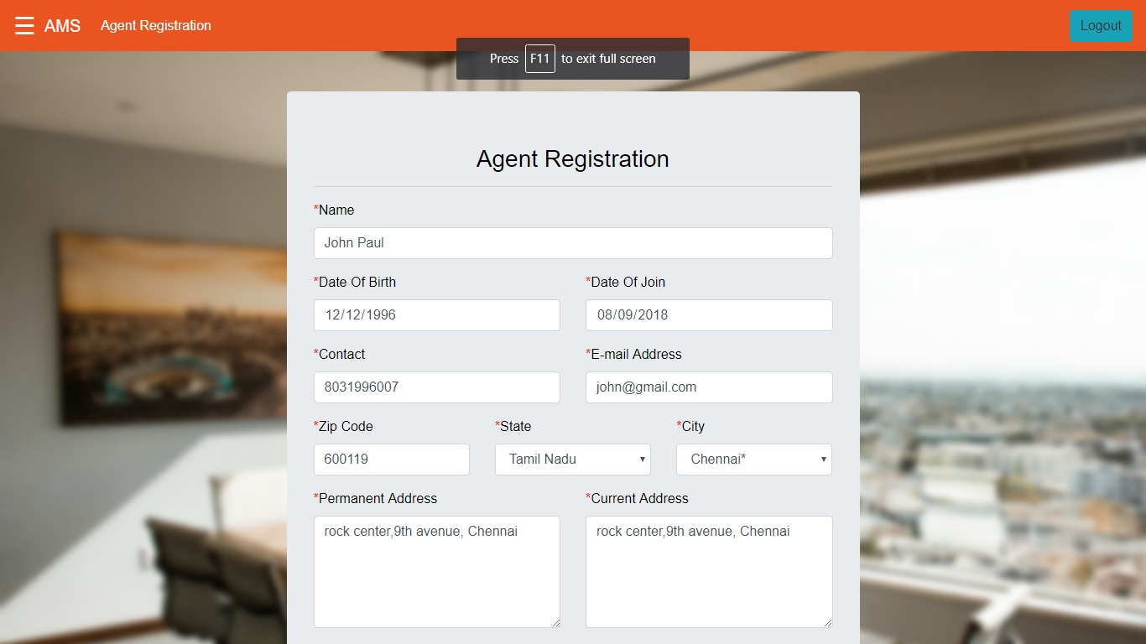

Output -

*Registration Successful*

*Agent with ID AG0001 has been successfully registered!*

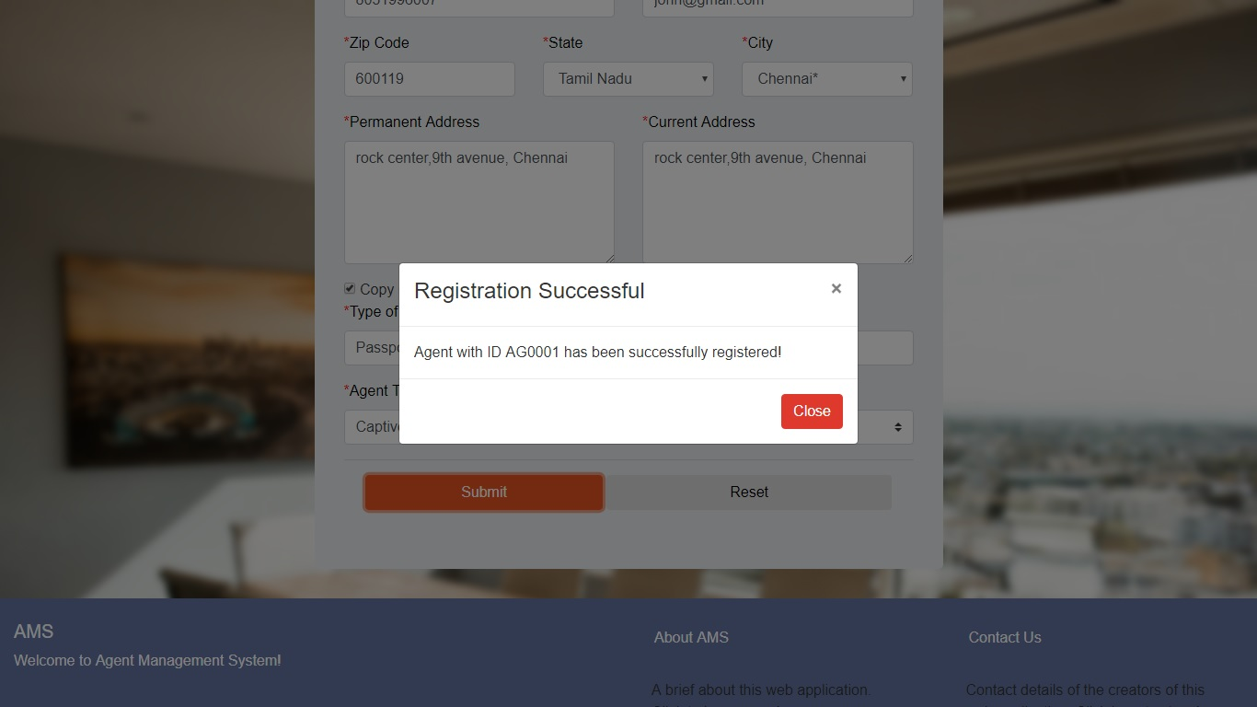

**#2**

* *Name- Ramu Prasad*
* *DOB- 12/11/1990*
* *Date-of-join - 01/02/2016*
* *Contact – 7676565434*
* *Email –* [*ramup@gmail.com*](mailto:ramup@gmail.com)
* *City – Bokaro Steel City*
* *State - Jharkhand*
* *Pin code – 834556*
* *Current Address – Laxmi Niwas*
* *Permanent Address- Abode Estates*
* *Type of proof – Aadhar card*
* *Passport no – 454656564543*
* *Agent type – Independent*

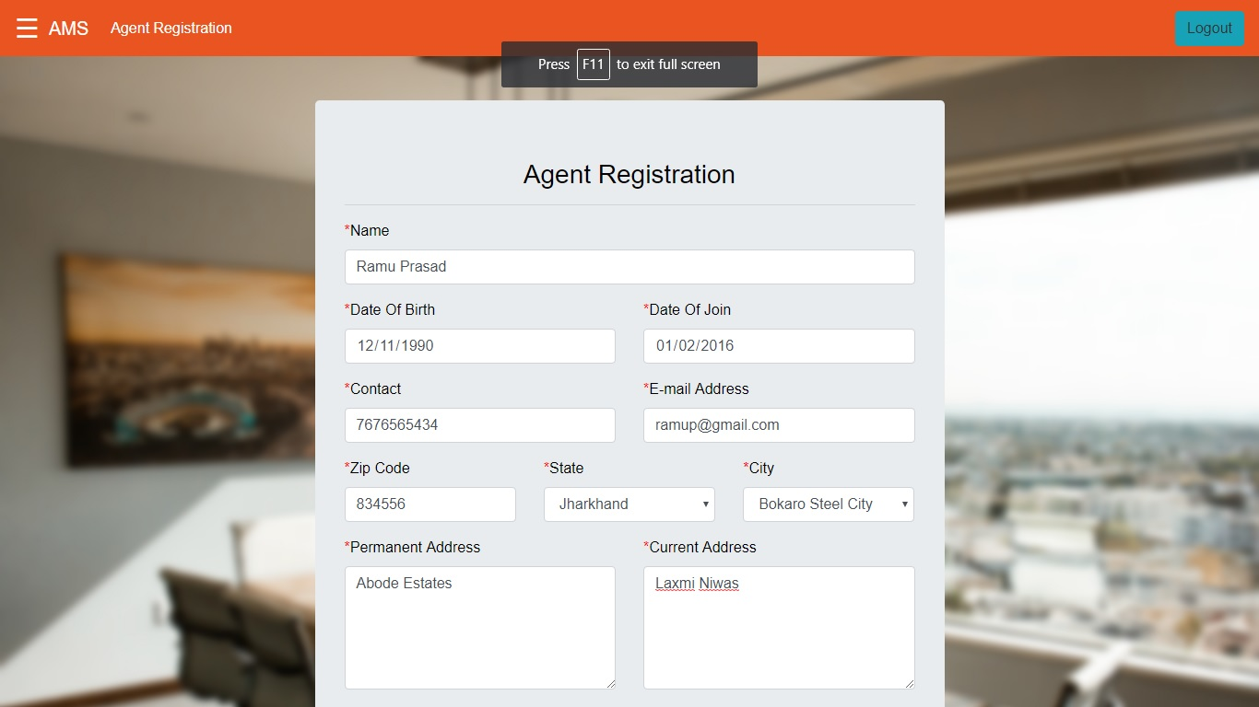

Output -

*Registration Successful*

*Agent with ID AG0002 has been successfully registered!*

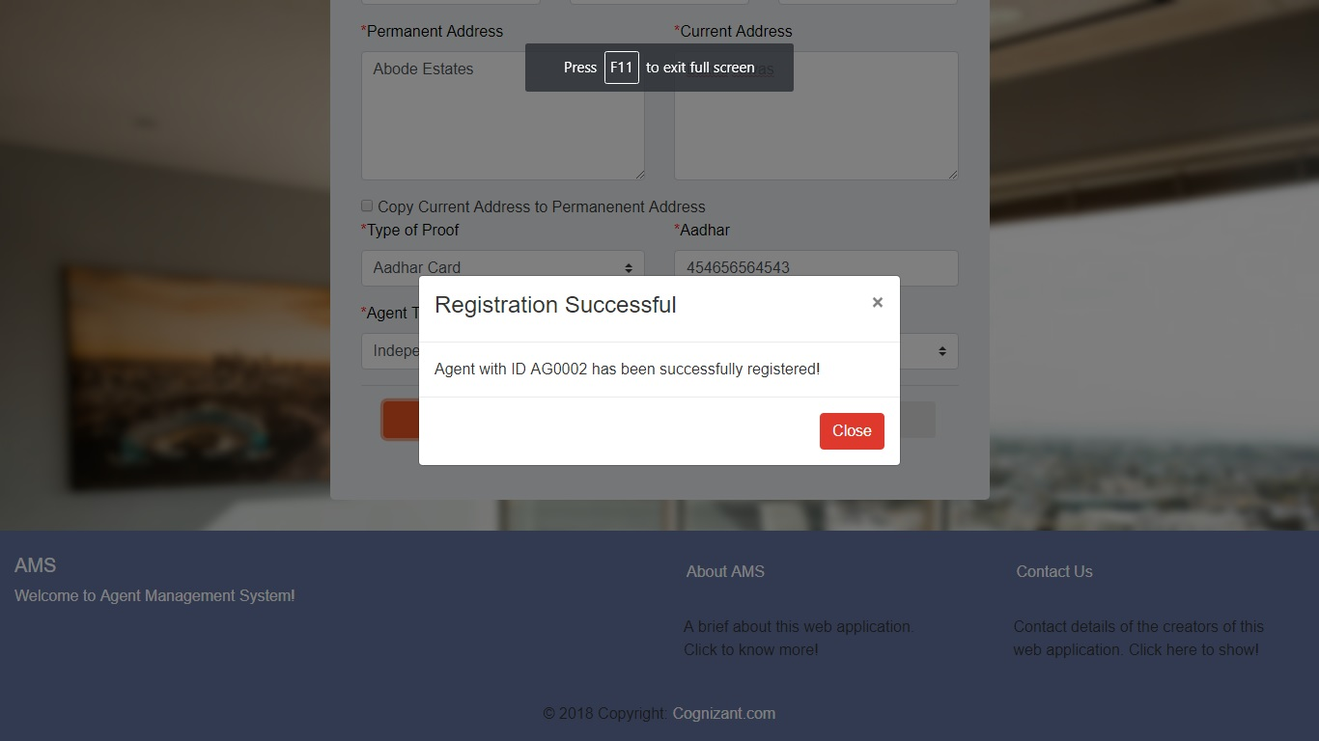

**#3**

* *Name- Dinesh Singh*
* *DOB- 11/07/1994*
* *Date-of-join - 01/03/2018*
* *Contact – 9876787654*
* *Email –* [*dineshs@gmail.com*](mailto:dineshs@gmail.com)
* *City – Shamgarh*
* *State – Madhya Pradesh*
* *Pin code – 787676*
* *Current Address – House No. 67, Naya Lane*
* *Permanent Address- Door 66, Hospital Road*
* *Type of proof – Voter ID*
* *Passport no – TYD8787676*
* *Agent type – Captive*

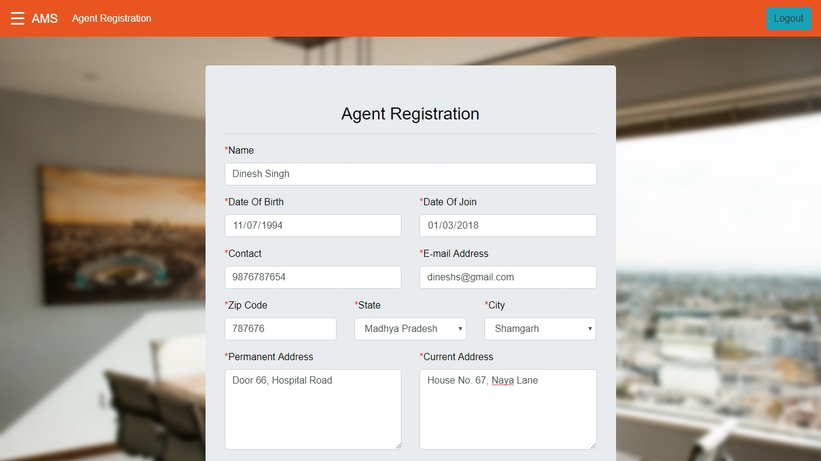

Output -

*Registration Successful*

*Agent with ID AG0003 has been successfully registered!*

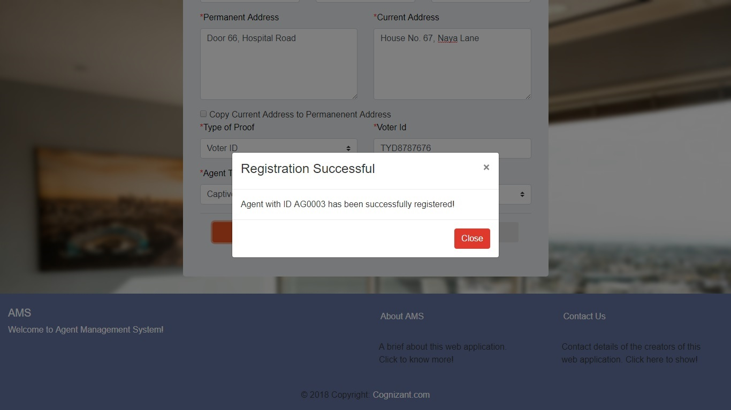

**#4**

* *Name- John Doe*
* *DOB- 12/26/1991*
* *Date-of-join - 11/01/2018*
* *Contact – 98756765434*
* *Email – abcici.com*
* *City - Dharmavaram*
* *State – Andhra Pradesh*
* *Pin code – 600097*
* *Current Address – 5/323, Creek Street, Sri Sowdeswari Nagar*
* *Permanent Address- 5/323, Creek Street, Sri Sowdeswari Nagar*
* *Type of proof – Aadhar card*
* *Aadhar – 56565656565*
* *Agent type – Independent*

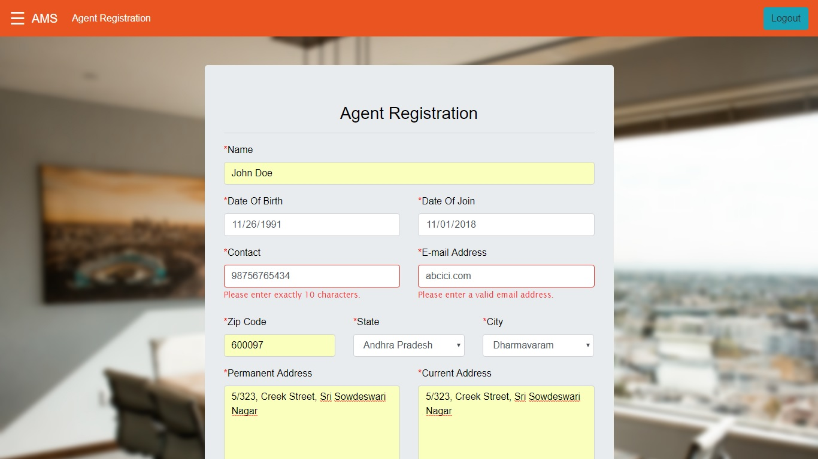

Output -

*The following error messages are displayed below respective fields:*

*Please enter exactly 10 characters.*

*Please enter a valid email address.*

*Please enter exactly 12 characters.*

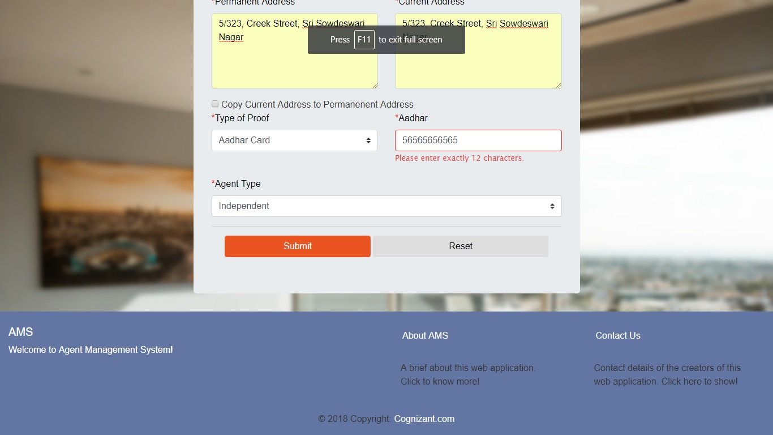

**#5**

* *Name- John Doe*
* *DOB- 12/26/1991*
* *Date-of-join - 11/01/2018*
* *Contact – 9875676543*
* *Email – ab@cici.com*
* *City - Dharmavaram*
* *State – Andhra Pradesh*
* *Pin code – 600097*
* *Current Address – 5/323, Creek Street, Sri Sowdeswari Nagar*
* *Permanent Address- 5/323, Creek Street, Sri Sowdeswari Nagar*
* *Type of proof – Aadhar card*
* *Aadhar – 565656565654*
* *Agent type – Independent*

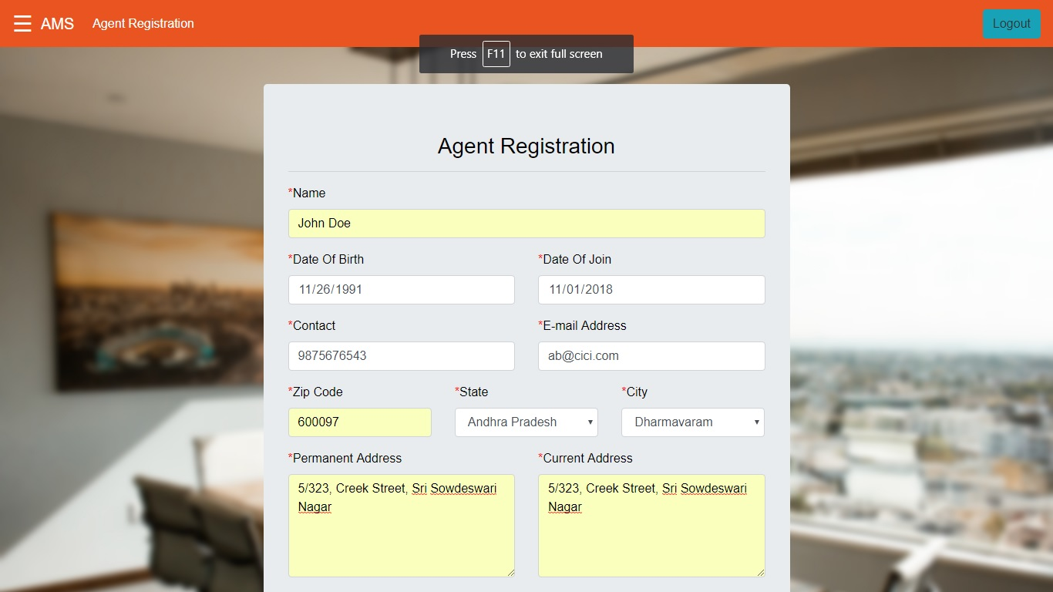

Output -

*Registration Successful*

*Agent with ID AG0004 has been successfully registered!*

